**Notes on Perspective  
A Visual Study of Kairos in Data Visualization**

## **Abstract**

*Leading Question*

How does embodying data from different viewpoints forming in experienced time help us come to terms with the judgments and beliefs we share with or reject from others?

*Notes on Perspective: The Data Visualization*

Notes on Perspective visualizes how different judgements are formed moment-by-moment when witnessing a live classical musical performance. It is a project that primarily explores how we can design embodied data from multi-dimensional perspectives within the experience of time..

*A Data Visualization of Sentiment Unfolding in Kairos Time*

The visualization aims to facilitate the communication of how overlaps in reaction and sentiment occurring simultaneously in time may be mapped in an “experience of time”. This project was inspired by data visualization techniques to immerse viewers in the unfolding of data meaning, particularly in datasets where each data point contributes to an unfolding of meaning over time.

*Data Visualization Precedents, Methods and Techniques*

Data visualization techniques and methods are drawn experientially from digital interactive narrative experiences such as gaming, digital media and animation and made technically possible by mobile web application development, database accessibility, communication between data web applications and databases as well as the languages that make it possible to structure and therefore materialize meaning and experience as digital artifacts.

## Table of Contents

Abstract

Table of Contents

I. About the Project

Objective

Purpose of the Data Visualization

Approaches Examined in this Data Visualization

Contents of Paper

II. Data Visualization in Kairos

Why Design Data Visualizations in Kairos?

Representation of Time

How do we currently see time?

Knowing absolute time

Experiencing relative time

III. Embodied Time Data, Multidimensional Data and Designing Signature Moments

Embodied Time

What is Embodied Time?

When Embodied Time is Cognitively Modified

When Embodied Time is less Cognitively Modified

When the Digital Medium Modifies our Sense of Embodied Time

Multidimensional Data

A first in interactive multi-dimensional experiences

Multi-dimensional experiences from more than 2 perspectives

Creating embodied experiences using multi-dimensional data

Signature Moments in Data

Giorgia Lupi

Valentina D'EFilippo

IV. Design & Development Process

Precedents

Histography.io by Matan Stauber

50 Years Swiss Music Charts by D|One

Reimagine the Game by the Economist

One Angry Bird by Periscopic

Issues and Limitations of Visualizing Kairos

The Data Visualization: Notes On Perspective

Data Architecture

Design Elements

Exploratory Data Visualization Findings

Prototypes Designed

Final Data Visualization

Limitations and Continuing Research

V. Summary

Referenced Projects

## 

## **I. About the Project**

When does society experience moments where we diverge from our fellow citizens in what we believe to be good, true, beautiful, just? What does that space look like? Can we follow strings of moments from multiple perspectives to see how judgments are formed? If we visualize this unfolding, can we see how we grow to agree or disagree, perhaps come back together, or diverge yet again with others over the course of time?

### Objective

**About the Dataset**

For this thesis, I worked with a temporally bound data set made up of the real-time opinions of musicians and audience members listening to Opus 73 by Schumann, complied by Michael Schober and Neta Spiro in their research study *Classical chamber musicians’ shared understanding: A case study*, in order to explore the notions of embodiment and multidimensionality in a visualization that represents the unfolding of judgement over time.

Notes on Perspective focuses on a very specific dataset: a dataset of reactions and sentiments experienced during a live classical music performance from various perspectives in New York City (Forthcoming). What can be generalized from this specialized research study are the methods and techniques in data visualization proposed to demonstrate the unfolding and forming of judgments in embodied time.

**Advantages of this Dataset for a Visual Study of Kairos**

The particular advantages of this dataset that makes it a unique candidate for the purpose described are: 1) the cleanliness of data captured from well-defined perspectives or roles (performers, audience, back-up performers), 2) the encapsulation of data in a demarcated space and time i.e. clear beginning and end with reactions that can be tied to an identifiable moments in time, 3) the choice of a classical concert hall as the setting- an example of a silent listening situation as opposed to a noisy listening situation and 4) using what is readily understood as a shared attention event i.e. the musical performance.

The visualization is both a vehicle for explaining the research study findings for cognitive psychology researchers interested in shared attention as well as a data visualization experiment in making data points within time tangible. The collaboration works together to show how research in joint attention, specifically in musical performances, can inform understanding of visualizing the narrative of individual judgment formation in a collective. This includes, for example: 1) integrative attention, which is the monitoring of one’s own personal judgment above others while monitoring the overall moment and 2) adaptive timing, or adjusting one’s moments in response to unanticipated changes in the event (Keller 2008, 205-221).

*“Because of the intimate coupling between perception and action, music provides a panoramic window through which we can examine the neural organization of complex behaviors that are at the core of human nature.”*Petr Janata, Nature and Neuroscience (Janata and Grafton 2003, 682-7)

### Purpose of the Data Visualization

Making time tangible, as possible through digital manipulation, serves the purpose to bring data points within a time bound dataset under intimate examination as a catalyst for new hypotheses. In other words, what types of interactions might we be able to actually see that we might not have anticipated? This may help, for example, see the part of phenomena such as overlaps and divergence in perspectives clearly generating unique signatures for each moment in time; the composition of those unique signatures creating fragmented views that may journey close together, continue to splinter, and/or unite in fleeting moments.

Specifically, data visualizations that have been built for screen interaction with an interactor, primarily through javascript and javascript technologies are investigated in this paper. This does not limit the considerations of this paper to visualizations that may come to be designed using future technologies; the precedents selected are due to their accessibility based on current technologies at the time this paper was written.

### Approaches Examined in this Data Visualization

Several data visualizations, through the way they build new possibilities to traverse data points in space-time, and visually read a recaptured analysis of sentiment occurring over time, have been selected as precedents and point of departure.

**Embodied Data**

Making data points captured during an event tangible. For example: rewind, manipulate speed, follow in real-time and drill down into certain moments to better understand the play-by-play of an event.

**Multidimensional Data**

Displaying the multiplicity of data from multiple perspectives in single views; see overlaps and divergence in sentiment in real time

**Signature Moments in Data**

Using visual metaphors in data visualization to contain unique signatures, or combinations of important attributes and variables, in the data.

### Contents of Paper

This paper further explains the research problem behind visualizing time and changing perception of time as an abstract sovereign measure, as well as precedents in digital technology for embodying narrative from multiple perspectives. It will also touch on research in joint attention in musical performances and how these events can enlighten our thinking around multidimensional perspectives generated in a shared time, space and focus of attention. I will discuss in detail the methods attempted and implemented in building such a visualization throughout the process, and learnings from any challenges and insights along the way. Finally, I will explore the limitations of this project to fully manifest the objectives it set out to accomplish, as well as thoughts and conclusions.

## 

## **II. Data Visualization in Kairos**

#### Why Design Data Visualizations in Kairos?

Time is organized in a manner that many understand as “linear”. The complement to this understanding of time can be similarly understood as “becoming” (West-Pavlov 2013). With the proliferation of data collection through means such as mobile self-reporting and tracking sensor devices, what Ajana refers to as “metric culture”, we are moving away from raw reports of our accumulated data points (Ajana 2018). This calls for a visual experiences and languages that lets data gatherers, users and designers articulate meaning in experiences, perspectives, and data points within a time-bound event; where meaning is found through re-experience and reflection -- for example: plays, songs, musical performances, movies, surveys of migrant refugees at certain times of refugee crises, among many others.

### Representation of Time

How have we come “know” what time looks like? In the scientific community, there is currently no consensus on “how or even where” time is processed in the human brain (Wittmann 2013, 217-223). Currently, the compiled consensus around time representation might be summed up as “we *know* absolute time and *experience* relative time”. Absolute time as in Newtonian time that gives us calendars and watches; relative time as in Einstein’s gift that spawned understanding in quantum mechanics. An experiment on participants’ control over a left- or right- gazing digital avatar upon hearing words associated with past, present or future suggests time might be naturally embodied in left/right or top/down mechanisms according to a “horizontal mental time line” (Thönes et al. 2018, 419-427). Whether this particular mental representation of time’s is directly related to our embodied experience is debatable. There is much room for additional research on how humans might learn to inhabit other representations of time by interacting with 3d or multidimensional representations.

Notes on Perspective purses a visual study of Kairos in data visualization. A visual study of Kairos complements the significant amount of effort achieved in visualizing data in Chronos. Joseph Priestley and William Playfair are known for their chronometrical visualizations, considered by many as the first to design time-series line charts and bar charts in published report (Rosenberg 2007, 55-103) (Spence 2006). In Chronos, idea of time is conceived as a continually moving line moving from the past into the future*.* It is helpful with providing us with a final snapshot of a dataset from an omniscient point of view. Kairos is the idea that the process of becoming equals time. A dataset experienced through Kairos can further elaborate how one data point composes the next in lived experience.

#### How do we currently see time?

The evidence for the existence of a mental timeline that orients our visual familiarity with time representation points to research suggesting “humans do not process time and space separately but represent time as space” (Bonato, Zorzi, and Umiltà 2012). Findings were taken from numerical cognition, visuospatial attention, response compatibility or embodied cognition (Bonato, Zorzi, and Umiltà 2012). There are mental timelines proposed that point towards both chronometrical and relative representations of time.

#### Knowing absolute time

Absolute time, chronometrical, universal or Newtonian time has been represented through many devices easily understood along the “horizontal” and “vertical” mental timelines (West Pavlov 2013). From this point of view, time is organized in a “spatial continuum akin to a line, where time flows from one extremity towards the other” i.e. from the past to the present (Bonato, Zorzi, and Umiltà 2012). Dominating conventions use left to right representations of time in most Western traditions (Santiago et al. 2007, 512-516), and both left to right and top to bottom in Eastern traditions (GU Yan-Yan and ZHANG Zhi-Jie 2012). This “measurable time” can be divided and subdivided into incrementally smaller units for the purpose of marking events along a fluidly advancing tape abstracted outside of us. Familiar devices that use this design are clocks, calendars and line graphs (West-Pavlov 2013). Admittedly, these devices of representations of absolute time are “riddled with issues of power and hegemony”; for example, calendars were the creation of political elites” (West-Pavlov 2013). However, the universal standardization of absolute time for industrial production and mass organization makes it a model of time most people are familiar with.

#### Experiencing relative time

Relative time, in contrast, does not privilege an “outside looking in” perspective of time. This Einsteinian definition of time is dependent upon the body of subject’s frame of reference in a time-space continuum where events can happen simultaneously (West-Pavlov 2013). According to Jankélévitch, “For every step into the future, there is a composition of the past...*preterition*” (Looney 2015). This preterition role in the design of the future might be understood as the body of data with a certain feature set inclining it towards certain trends or patterns. When experiencing time, any data point(s) that precedes another can be critical contextual information to explain the possibilities that arise for the next. Certain intervals of datapoint inhabitance may be “restored” to the lived, or embodied experience of anticipation and expectations. For example, representations of datasets in time that allow you to revisit and recapture the embodied experience.

## III. Embodied Time Data, Multidimensional Data and Designing Signature Moments

## Embodied Time

### What is Embodied Time?

Cognitive science has proposed that “embodied cognition”, or the role in how our bodies and their motion physically navigate the world has much more to do with how we represent the world internally than we may think, is perhaps radical in its claim that they are “replacing the need for complex internal mental representations” (Wilson and Golonka 2013). It is surprising because the brain “is not the sole cognitive resource we have to solve problems” (Wilson and Golonka 2013), which is not as much surprising as having proven difficult to prove. Now that they are proving it, it necessarily opens up the floodgates of all the ways we might represent things through our bodies and motion without much neurological effort. Time is one of those things proposed. One very specific empirical example being “evidence linking the insular cortex to implicit temporal mechanisms for creating mental presence”; emotions’ integration with a higher-order mechanism for 2 to 3 seconds that defines the present moment or the feeling of nowness (Wittmann 2014, 507-523)

### When Embodied Time *is* Cognitively Modified

**The relation between affect and representation of duration in the brain**

Factors such as emotion and physical state impacts our experience of duration. For example, aroused states such as anticipating an electric shock, thinking about a phobia, an increase in body temperature or pain is associated with longer duration estimates (Wittmann 2013, 217-223). We also process experiences above 300 milliseconds differently from those below 300 milliseconds, introducing hypotheses that the former may be modified by cognitive capacities, while the latter may not be (Wittmann 2013, 217-223).

### When Embodied Time *is less* Cognitively Modified

There are several interesting pathways towards when embodied experience is less cognitively modified. For example, developmental psychologists have proposed that the bodily experience of force is essential to thought and language (Port and Gelder 1995). When it comes to embodied time in particular, cognitive scientists have proposed that in studies of robots and animals, the possession of available resource to solve problems in a given setting or environment is enough to accomplish the tasks at hand (Wilson and Golonka 2013).

### When the Digital Medium Modifies our Sense of Embodied Time

**Representation of time in digital narrative artifacts**

Digital narrative artifacts, notably games and digital fiction media, use understandings of divided attention to construct “sped up” manipulations of events in time.

## Multidimensional Data

### A first in interactive multi-dimensional experiences

A classic example of one of the earliest multidimensional experiences created was Hole In Space, an public communication sculpture by Kit Galloway and Sherrie Rabinowitz in November 1980 (Galloway and Rabinowitz 1980). This experience was exemplary of what we are now familiar with as real-time video telecommunication. Placing one monitor in a Los Angeles’ Culver City shopping mall and the other in New York City’s Lincoln Center without any explanation or prior warning, recorded videos show passerby congregating in wonder, surprise and disbelief when told that those they saw on the monitor were not only reacting to them in real-time, but that they were not hired actors, simply ordinary people who were able to see and hear them at the same time in another location (Cho 2018). As one of the first artistic experiments that used the affordance of the digital medium to design interaction for different roles simultaneously at this scale, we can continue to appreciate how designing for real-time multiple perspectives to interact organically can be delightful, magical, and humorously unpredictable.

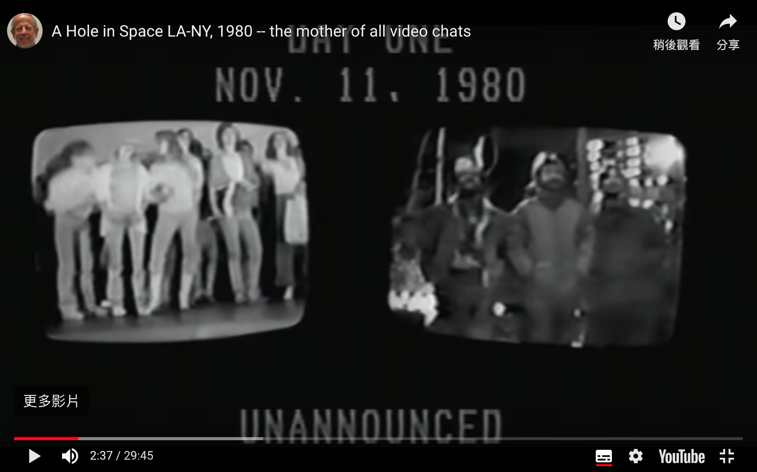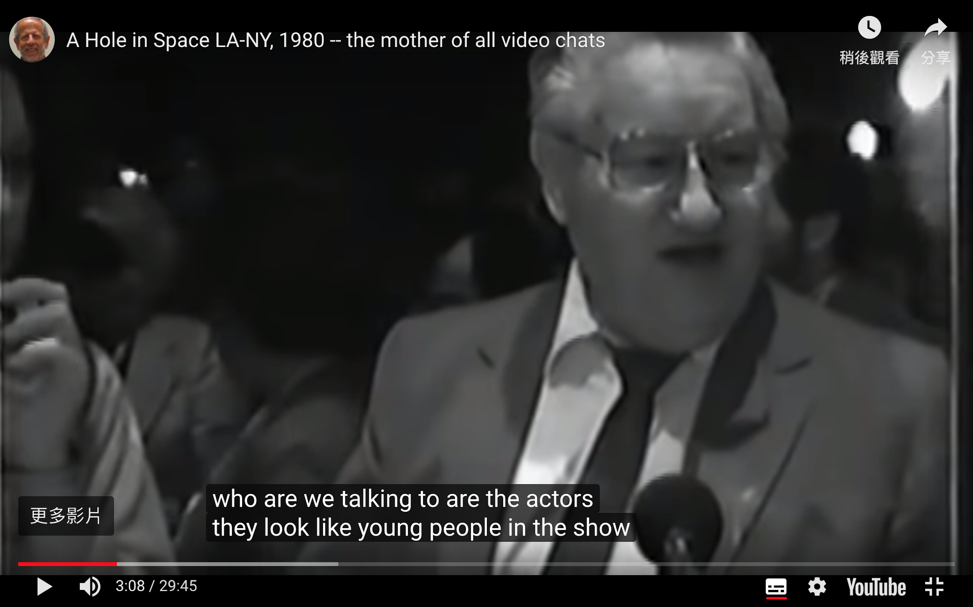

**Left to right:** Side-by-side display of crowds gathering in front of the installation at Culver City, LA and Lincoln Center, New York; Man wonders if the people on the videochat are hired actors in a pre-recorded video meant to convince them the feed is live (Press 2013).

### Multi-dimensional experiences from more than 2 perspectives

Hole-In-Space is an early multi-dimensional experience that surprised viewers with just two perspectives. More recent experiences further this capability, generating experiences from many more perspectives. CNN and Microsoft Photosynth, for example, recreated the 44th presidential inauguration from viewers’ inaugural photos, allowing interactors to relive the moment from any vantage point (Ostrow 2009). Virtual Reality and other Mixed Reality experiences are currently a popular medium effective for these purposes due to its heightened ability to elicit awe by heightening “presence” (Chirico et al. 2016).

### Creating embodied experiences using multi-dimensional data

In *The Message of Music,* Christian Moeller characteristically used data captured from different spatial locations during a live musical performance to create an embodied experience of multi-dimensional data. The final installation allows interactors to choose different locations to experience a playback of the performance, complete with “ghostly images of individual musicians... mirrored into the center of the installation space”, which “fade in and out of view according to listener’s remixing of the score” (Moeller 1996).

## Signature Moments in Data

The art of designing data visualizations from visual metaphors which generate visual signatures, or data points mapped to a custom visual code, have proven beautiful, stunning and powerful for affect-focused datasets such as art, music and history. The selected examples highlight classic examples of this data visualization method, as well as those especially relevant to this project.

### Giorgia Lupi

**The Lives of 10 Famous Painters**

Giorgia Lupi designed a well-known infographic for print publication that visualizes the history of selected famous artists constructed by mapping their biographical data to custom designed icons. This visual metaphor uses a chronometrical timeline from left to right (birth to death).

Simple shapes and elements use form and color to code events sequentially along the artists’ timeline, such as taking a lover, having sons or daughters, travelling, and artistic production.

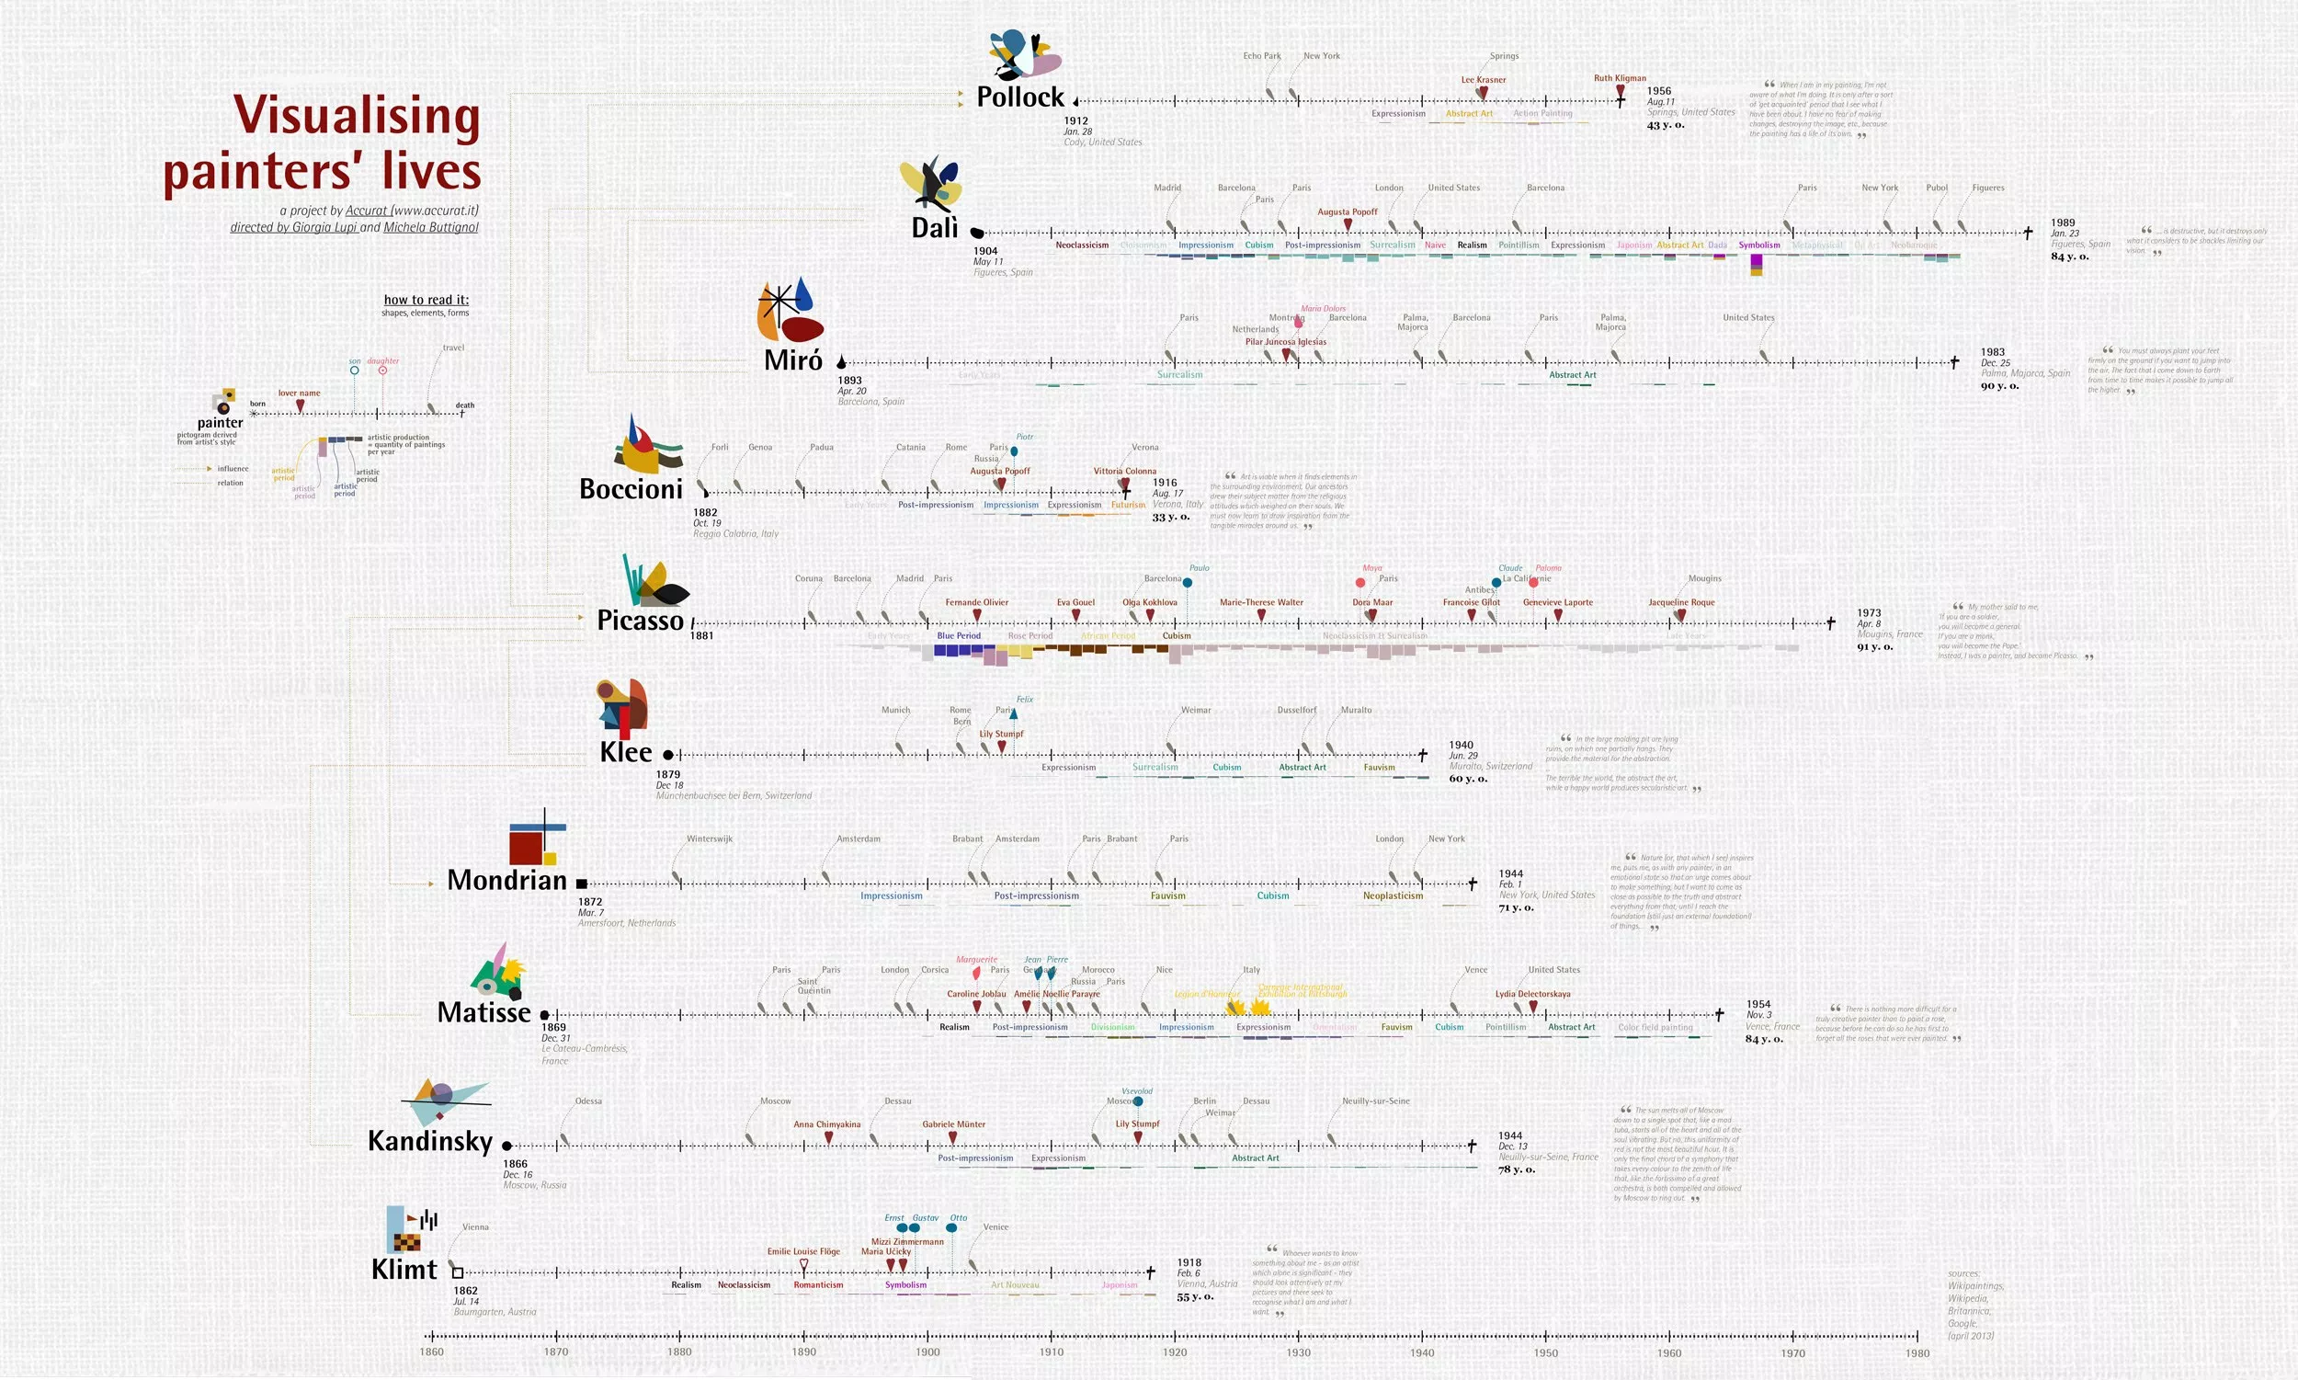



**Bruises — The Data We Don’t See**

A unique visualization designed using visual metaphor for a time-bound dataset that does not conform with the traditional “horizontal mental timeline” but still mappable to two-dimensional space is *Bruises* by Giorgia Lupi and team.

It chronicles the health and psychological condition of Kaki’s four month journey with a medical condition. The dataset used were days where Kaki’s platelet counts were measured, accompanied by the intensity of bruises and petechiae on her skin and Kaki’s level of positivity, cheerfulness.

The visual metaphor used were petals, and characteristics of that day were mapped to elements such as arrangement, color and texture. For example, the number of platelets were mapped to red dots reminiscent of pollen dusted on each petal. The distance between petals represents the time between platelet count days, the intensity of a bruise texture on the petals represented the extremity of Kaki’s bruises that day, and the presence of a yellow glow represented the extent of cheerfulness that day.

Notably, while the petals are sorted in groups where the distance between petals represents the time between platelet count days, they are not arranged in any other linear fashion; whether left to right or top to bottom. They are arranged as perhaps what they are in Kaki’s memory: a collection of memories in clusters.

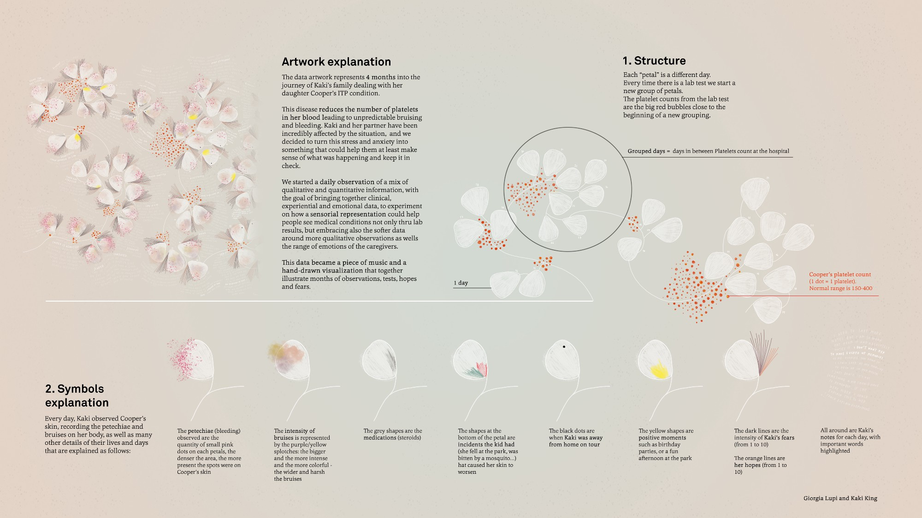



### Valentina D'EFilippo

Valentina D’EFilippo is a developer/designer that brings designing custom data signatures to represent characteristics of affect-riddled data to life in interactive web applications.

**Poppy Field**

Her project, Poppy Field, visualizes wars in history as poppies to invoke the tradition of using poppies as a commemoration of war due after World War I. The design is simple and powerful: the stem spans the years which it occurred, the size of the poppy represents number of deaths, and the petals on the poppies represent which continents were part of that war.

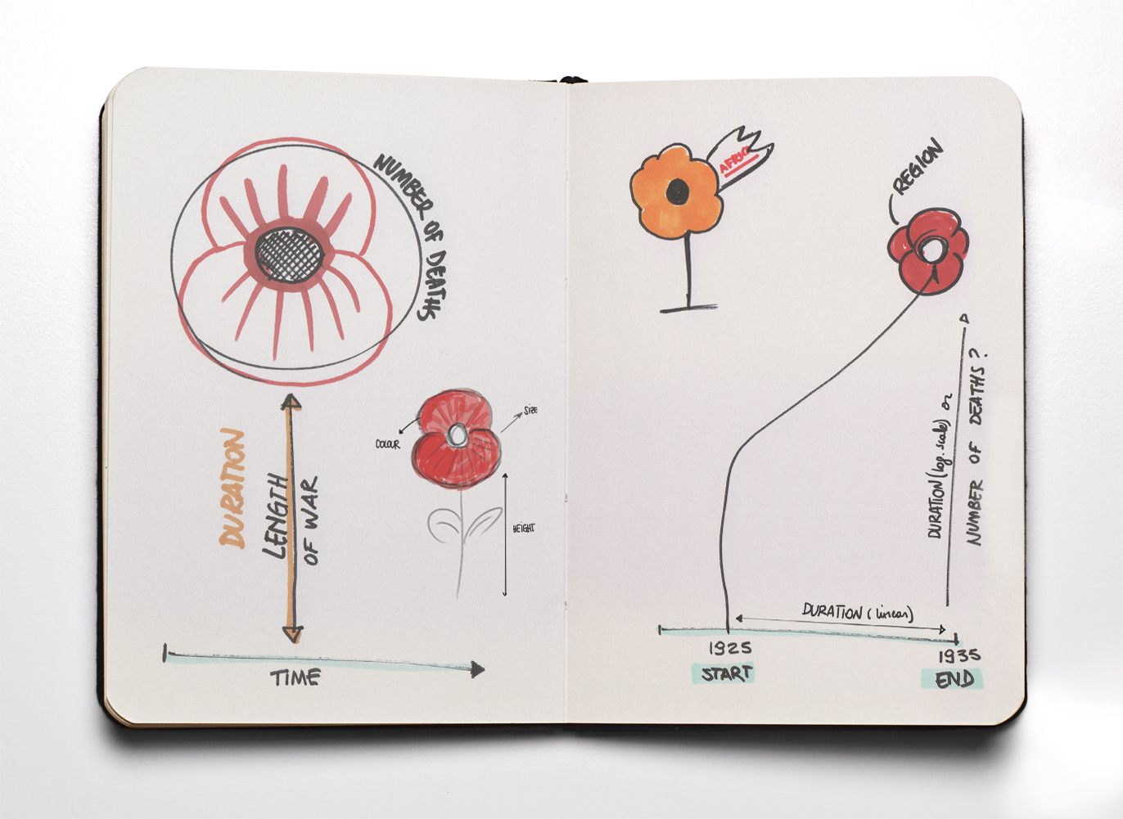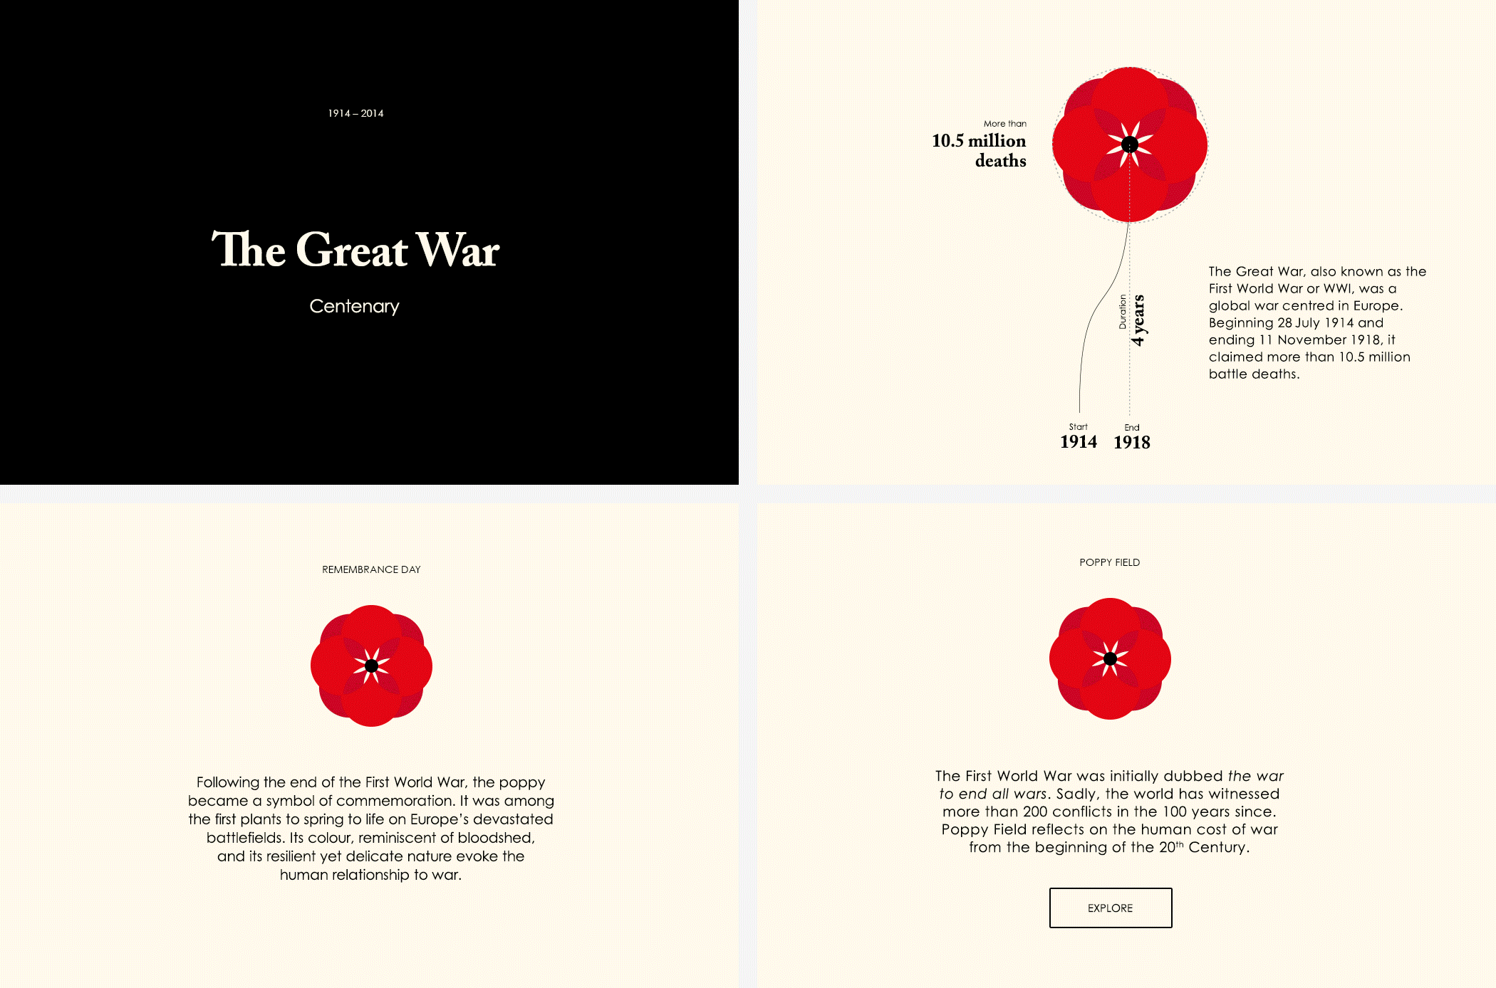

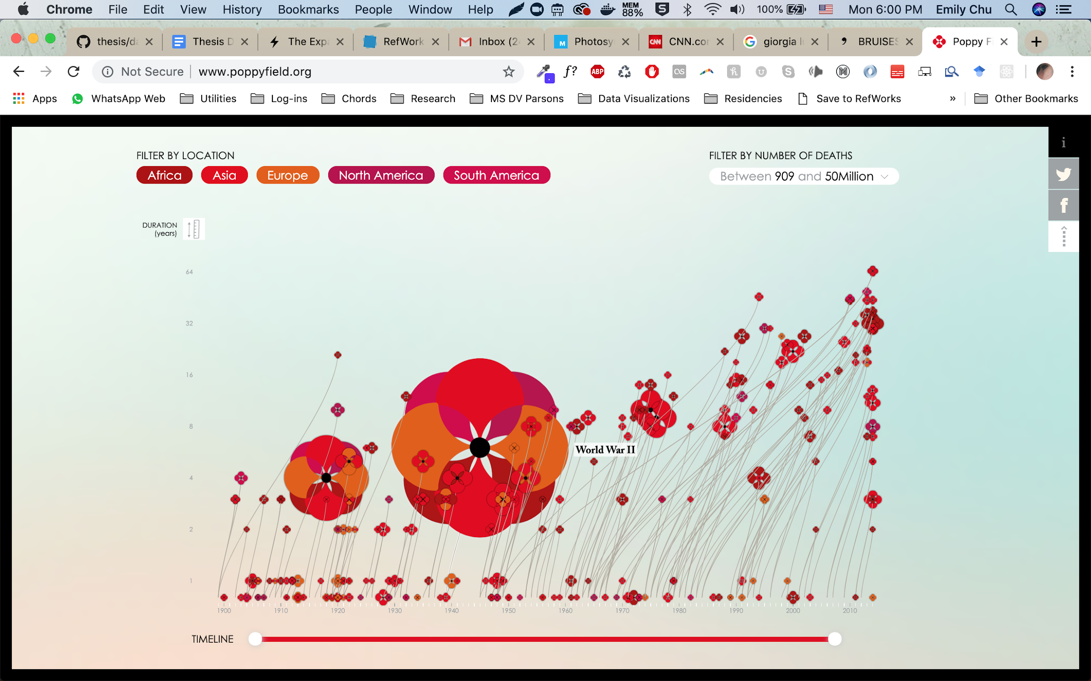

## **IV. Design & Development Process**

### Precedents

Precedents that experiment with identified data visualization methods to display data in Kairos time played an important part in framing the design process to stakeholders throughout the design and development process. They also show that visualizing data points in experienced time is an effort that is already underway and being implemented in the mainstream. Selected projects outlined below explore embodying data in experienced time, visualizing data captured from multiple perspectives in the same event and/or designing “signatures” from moment-by-moment data:

#### Histography.io by Matan Stauber

This data visualization by Matan Stauber takes a curated set of events from Wikipedia and visualizes them as points within the walls of a time tunnel spiraling from the outside in (Stauber 2015).



Based on the view selected, datapoints flow fluidly between the tunnel and chronometrical timeline means of structuring or embodying the datapoints. This design choice offers up the view of time as an organizing structure, and data located within time not as permanent localities but as placements of reference based on the preferred representation of time.

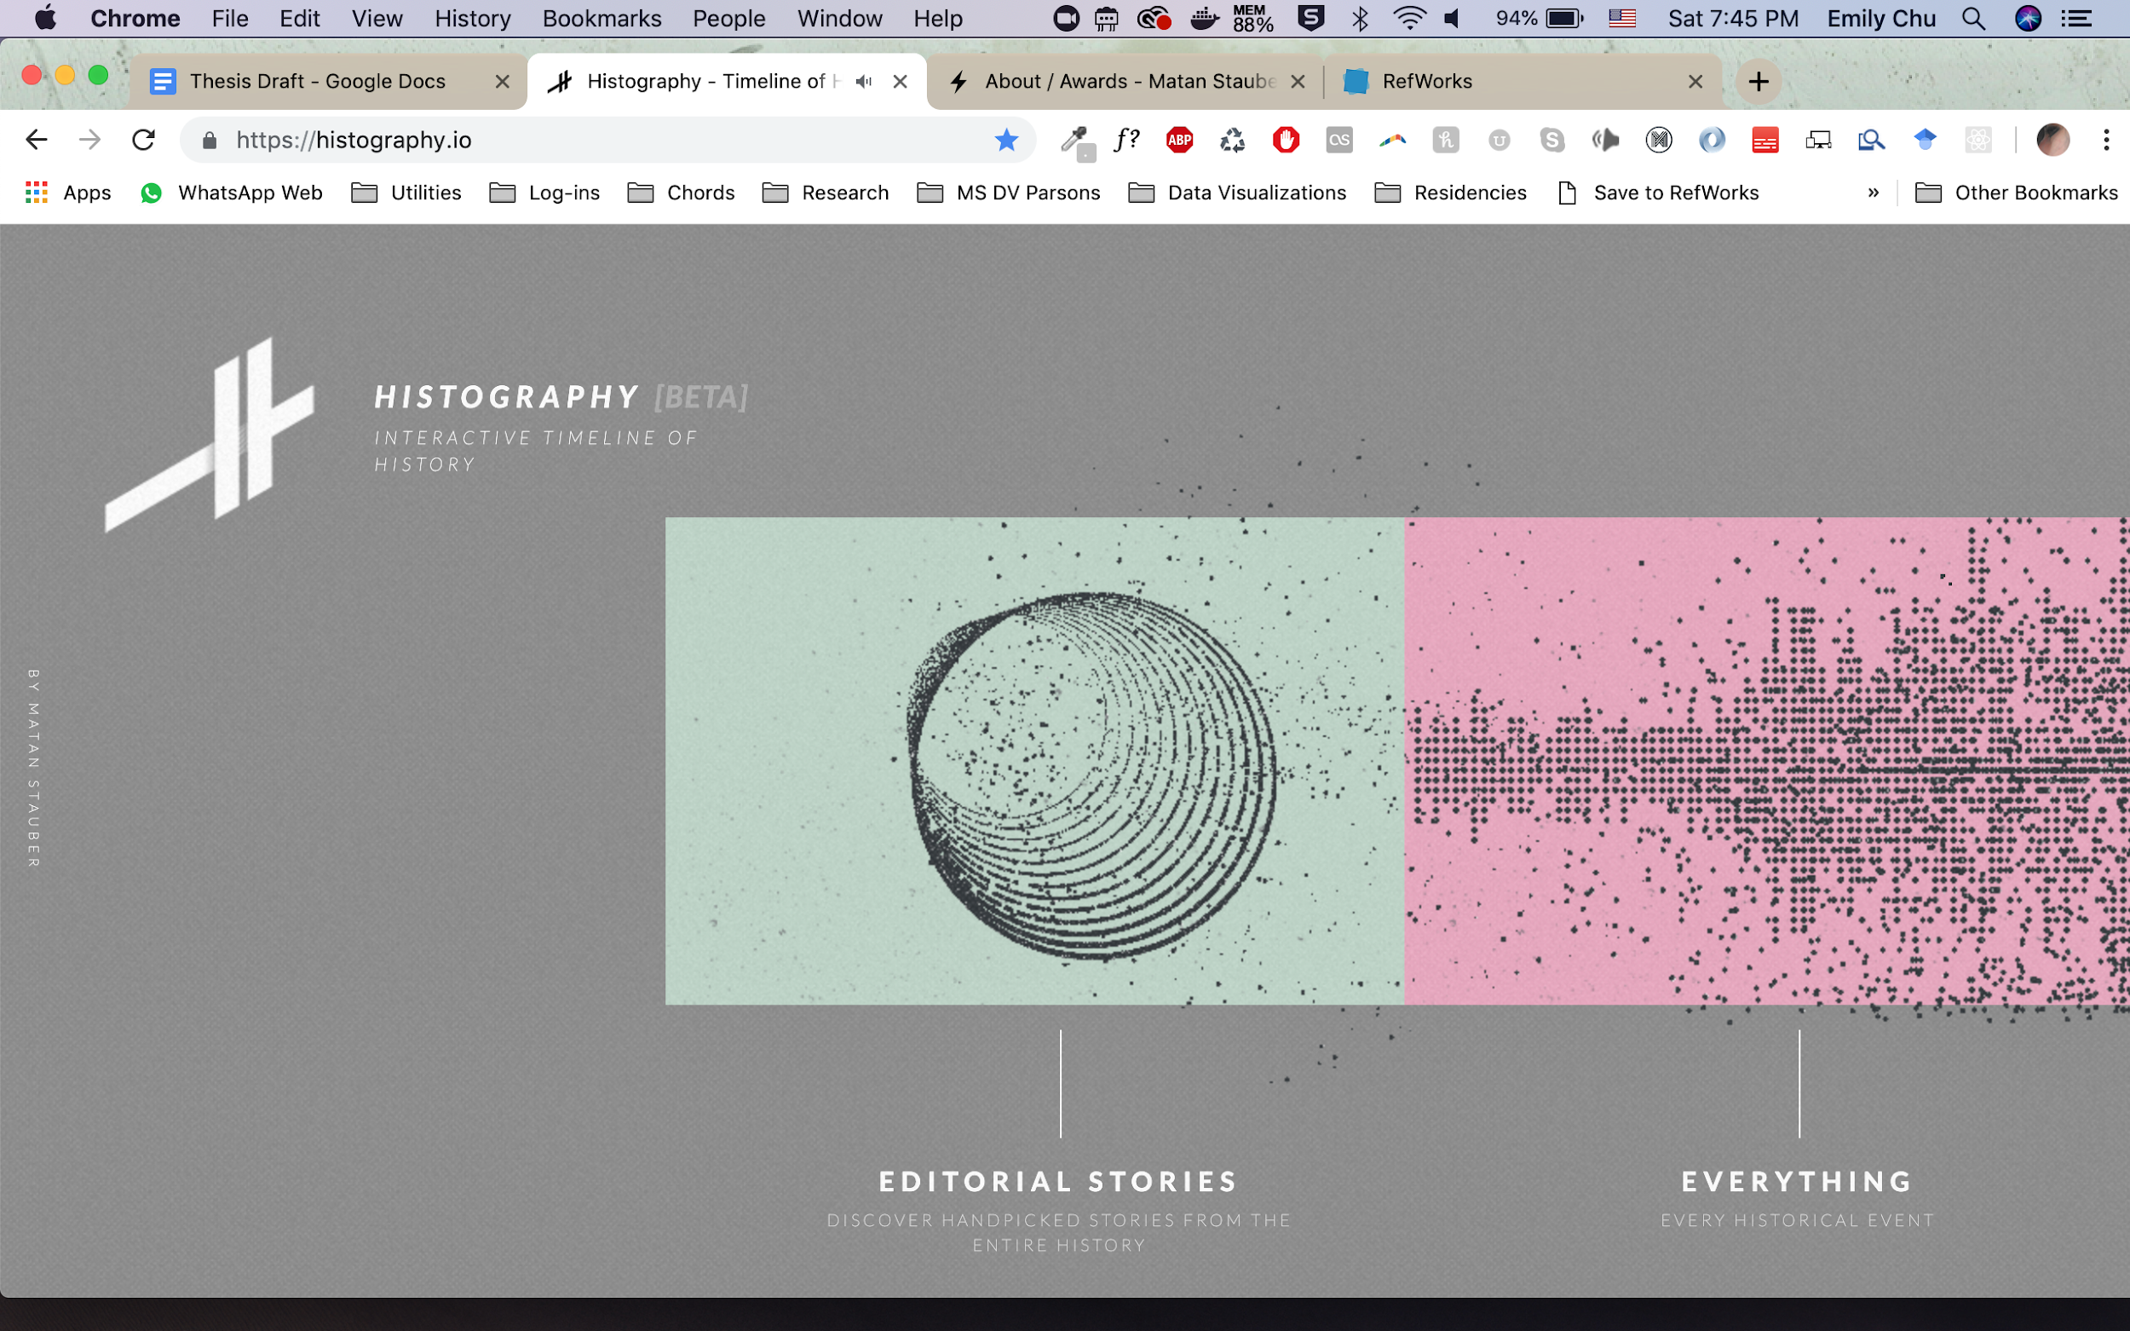

The interactivity of the visualization allows you to drill down into the metadata tied to each data point, such as image, wikipedia article text, link to any supporting media such as videos:



The “raw” event data points can also be organized in a chronometrical timeline view, following the familiar mental timeline flowing from left to right.

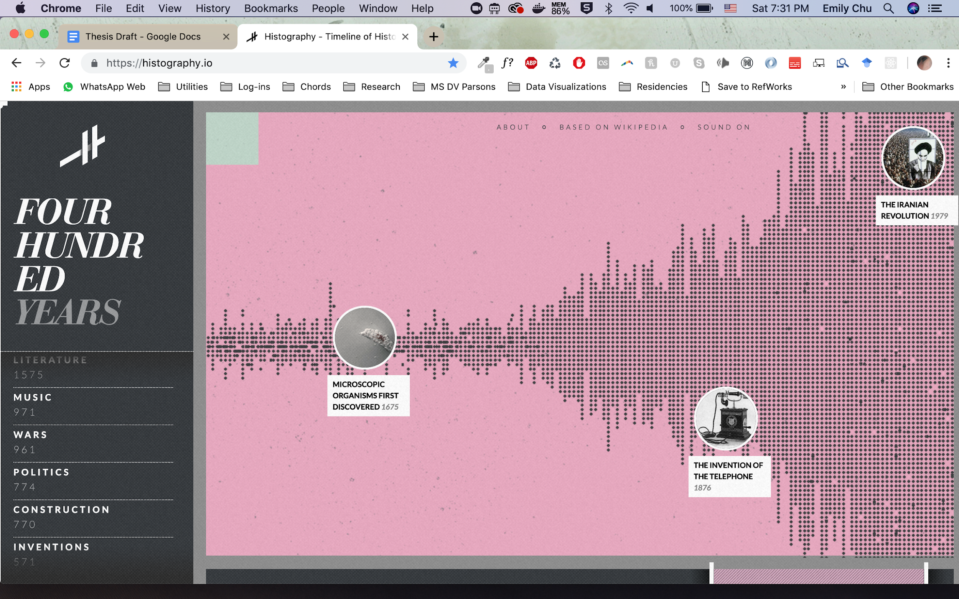

#### 50 Years Swiss Music Charts by D|One

In this data visualization by D|One, songs that topped the swiss music charts were organized into a universe experienced from 1968, which starts on the the outskirts to 2018, placed in the center (D|One ). To experience how the most popular songs progressed over time, the viewer is immersed in a three dimensional space where they both visually traverse into the present while their environment (constellations and audio representative of the most popular song in the moment in time) plays.

**Interactor scrolls into the center of the universe to traverse musical charts**

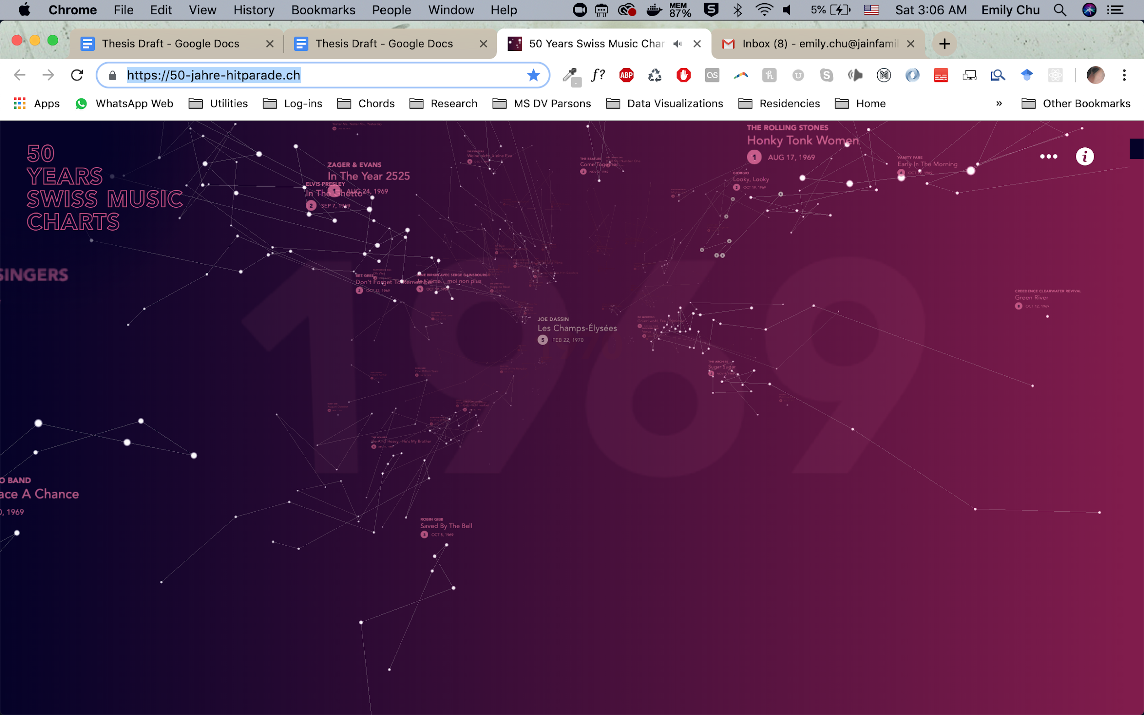

**How data-points of songs are mapped to signature constellations**

As the outside to inside time-space continuum embodies the experience of moving through time consistently throughout the experience, unique constellations are mapped from the placement and numbers of rankings for each song that topped the charts. The larger the constellation, the more times that song topped the music chart. The size and position of each star in the constellation represents its ranking; how horizontal it is represents the song’s mood.

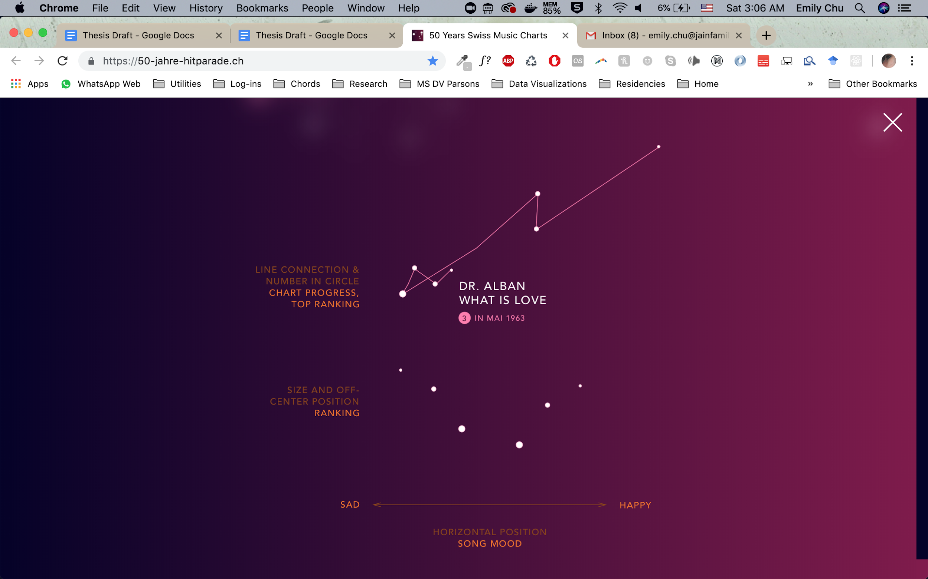

#### Reimagine the Game by the Economist

Reimagine the Game is a data visualization by the Economist that allows the interactor to play back any moment in the match and view the stadium’s reactions reconstructed spatially alongside audio playback of each moment in the match (The Economist ).

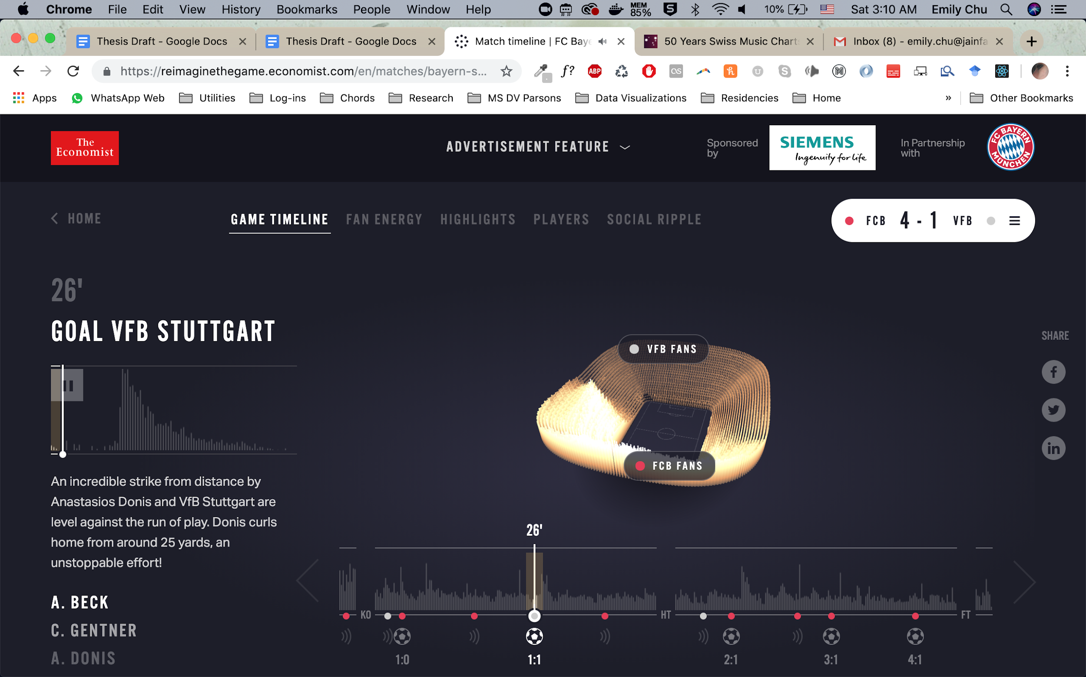

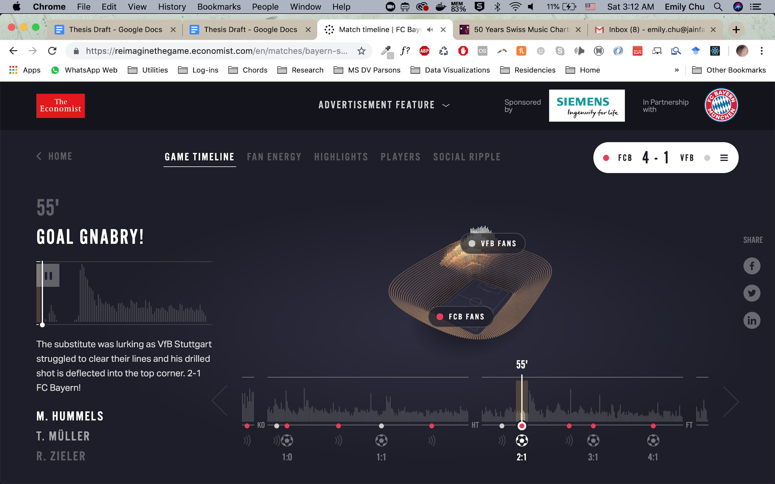

#### One Angry Bird by Periscopic

One Angry Bird by Periscope designed data visualizations coded by emotion and sentiment from the president’s expressions to generate unique feathers for each presidential inaugural address. It is important to note that each strand is mapped to a unique moment in the presidential address; feathers above the barb signify positive emotions and feathers below the barb signify negative emotions.

**How Feather Signatures were Mapped to Sentiment Data**

To generate visual signatures of generally “weak, positive, surprised” facial expressions in the president of each inaugural address in contrast to “strong, fearful, angry” inaugural addresses, for example, the Periscopic team created a sentiment and color code to map data to continuous (emotional strength), ordinal (positive, neutral or negative sentiments; primary and secondary emotions) and categorical data (happiness, fear/disgust/contempt, sadness, anger, surprise expressions).

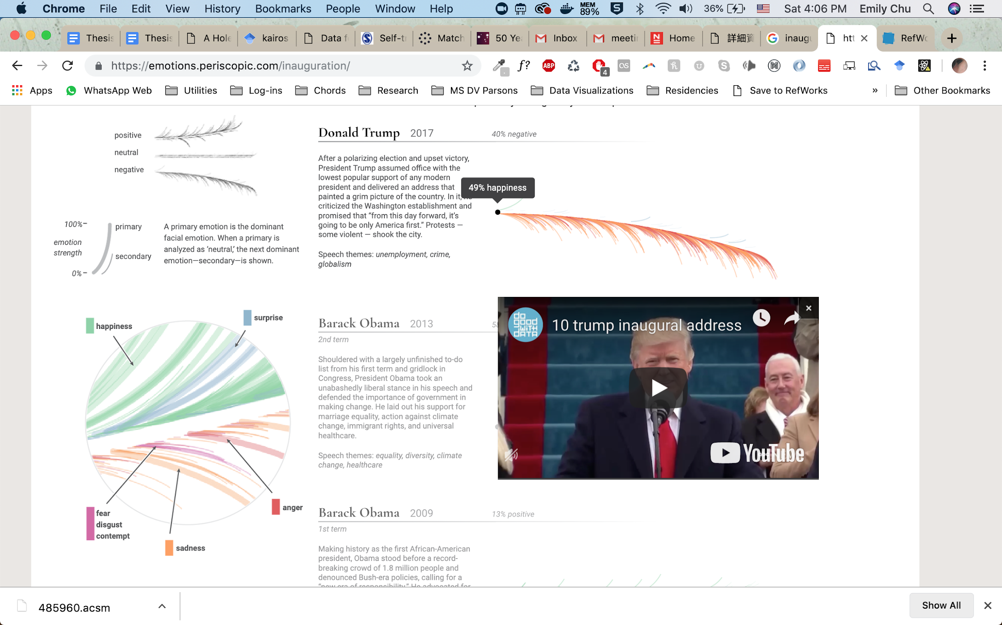

**Resulting Feather Signatures by Presidential Inaugural Address**

For each presidential inaugural address from 2005-2017, the resulting signatures can be seen in the small multiple view below. This set of data visualizations are a characteristic example of visual snapshots that offer viewers minimum effort to understand the major differences in datasets composed of individual moments but bounded within a single event.



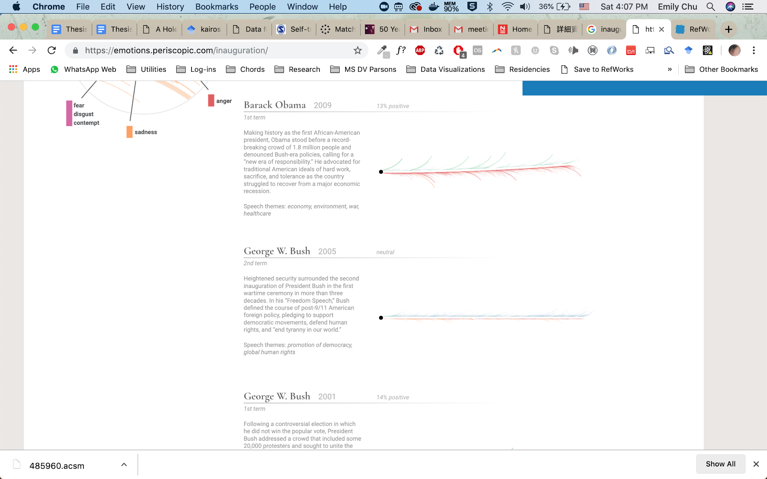

### Issues and Limitations of Visualizing Kairos

Major current issues and limitations of visualizing within data within Kairos examined in this project are:

**The hegemony of absolute, measured time**

Time has been standardized by absolute measures, including the calendar and the clock, into accepted divisions, such as years, months, days, hours, minutes, seconds, milliseconds and so on (West-Pavlov 2013). To understand anything within our framework of time, the way we read Chronos must be present in all visualizations of Kairos in some way to “understand where we are”.

**Representations of absolute, measured time**

Despite the indisputable hegemony of absolute, measured time - data visualizations have experimented with representations of absolute measured time beyond those characterized by a standardized “horizontal mental time line”.

**Narrative as the gateway of time**

Ricoeur says, “narrative as the guardian of time” and “there can be no time but narrated time” (West-Pavlov 2013). To understand data visualized in a kairos space effectively, narrative should be present to facilitate the understanding of essential concepts such as points of view, progression, sequence and becoming.

**Limits in Technology and Development**

This visual study of kairos in data visualization uses the ability to develop web applications, single page applications (SPAs) that individuals can interact with to a limited degree through a screen. The data visualization presented within this web application is limited to what can be represented and interacted with visually or auditory through such means. The success of this project is dependent upon the design choices made by the designer and developer of this project (myself, with the input of peers in my thesis course among others within my accessible community). The development of this project is also limited by the capabilities of the author.

### The Data Visualization: Notes On Perspective

Informed by the goals for visualizing data in Kairos time, work of precedents and presiding limitations, the following project build was designed:

#### Data Architecture

The data architecture and design decisions made in data structure based on the characteristics of the dataset used are explained further in this section.

*Reaction Data*

The raw data was collected from a series of surveys identifiable by role in the musical performance. Each survey is identifiable by the role of the author. Data captured from each individual participant through these surveys can be understood in six parts:

1. **Profile:** Identifiable information for each participant denoted their role in the performance (Performer, Class Member or Back-up Performer), a unique identifier integer (i.e. 1, 2, 3), what instrument they play if any (piano or cello), and whether they have any familiarity with the piece (have listened to, have played, have performed).
2. **First Moment Reaction**: this is a written comment that can be tied to specific measure(s) of the musical performance selected by the participant. Researchers then coded these comments into sentiment (positive or negative), and a best-fit subject matter category (dynamics, tempo, balance, rhythmic motion, synchronization, communication, matching musical idea, expressivity, tone quality ending).
3. **Second Moment Reaction:** Contains the same information as the First Moment Reaction for a different moment of the performance selected by the author.
4. **Third Moment Reaction:** Contains the same information as the First and Second Moment Reaction for a different moment of the performance selected by the author.
5. **General Reaction:** this is a written comment that summarizes the overall impression of the performance by the author. It is not tied to any specific measure in the piece; it is a general characterization of their judgement. Researchers also coded this by sentiment (positive or negative), whether it was a reaction to the music, performance or both.
6. **Peer Review:** Two other participants who also witnessed the same musical performance reviewed the moment reactions and general reaction. These reviews are identifiable by reviewer role and familiarity with the music (have listened to before and/or have played before). Researchers then coded these reviews as agreements or disagreements (same or different).

*Musical Performance Data*

To be able to visualize this information tied to the musical performance, a dataset was generated which includes beat by beat information:

* The measure (i.e. 1 to 67)
* The beat (i.e. 1 to 4)
* Timestamp at which the beat occurs in the musical performance audio file (i.e. 1.12)
* Reference to local image of the score tied to that beat (i.e. 1.png)

*Minimum Grouping, Sorting and Filtering Requirements*

The data must satisfy the minimum grouping, sorting and filtering requirements:

* Unique identifiers for each moment and general characteristic reaction
* Ability to group by role (i.e. performer, audience, back-up performer)
* Ability to group by instrument (for all performers, back-up performers, and audience members who specified ability to play the piano or cello)
* Filtering by reactions occuring in any particular moment (i.e. a specific beat or set of beats) with corresponding audio and score visuals available
* Ability to tie sort reactions by most similar (sentiment and category)

*Data Architecture Diagram*

[Insert data architecture diagram here]

#### Design Elements

[insert design elements prioritized by objective]

#### Exploratory Data Visualization Findings

[insert information on the exploratory data visualization and findings for what works and what doesn’t work; limitations of the dataset; advantages of the dataset; important meanings and insights to design around]

#### Prototypes Designed

* “**Immersive chronometrical”**: This digital prototype was designed as a linear visualization that follows the musical performance though audio playback and musical score images. As the audio plays back, the relevant portion of the score is visually highlighted. A comments section shows reactions pop up at moments of the performance they correspond to. The comments section offers basic filtering and grouping options, such as by role and by type of comment.
* **“Universe”:** This digital prototype is designed following a “multiplayer game perspective”. While the environment is the same, each perspective populates data points, or reactions particular to the selected role. To navigate in this immersive experience within time, the interactor traverses the musical performance from outside in.
* **“Signature”:** This digital prototype is designed following a visual metaphor custom designed for this dataset. Using the visual metaphor of musical notation where notes can fall above or below the staff, circles representing the quantity of reactions by category fall above or below a sentiment line, collective creating a moment-by-moment signature as the musical performance follows an audio playback tied to score visuals.
* **“Spatial reconstruction”**: This digital prototype follows a spatial reconstruction that accommodates spatially where different audience members were located in the musical performance. Sentiment throughout the musical performance are then expressed in these localities to spatially reconstruct how judgements were formed moment-by-moment in the musical performance.

#### Final Data Visualization

[information on the final data visualization]

#### Limitations and Continuing Research

[comments on where the prototypes and final data visualization leave room for additional issue resolution; learnings; next steps in this line of research]

## V. Summary

## Referenced Projects

<https://50-jahre-hitparade.ch/>

<https://reimaginethegame.economist.com/en/intro/>

<http://www.ecafe.com/getty/HIS/>

<https://www.cnet.com/news/microsofts-photosynth-captures-inaugural-moment/>

<https://christianmoeller.com/The-Expanded-Chamber-Scoring-the-Demix>

Bibliography

Ajana, Btihaj. 2018. *Metric Culture: Ontologies of Self-Tracking Practices*. First ed. United Kingdom: Emerald Publishing.

Bonato, Mario, Marco Zorzi, and Carlo Umiltà. 2012. "When Time is Space: Evidence for a Mental Time Line." *Neuroscience and Biobehavioral Reviews* 36. https://citeseerx.ist.psu.edu/viewdoc/download?doi=10.1.1.703.7921&rep=rep1&type=pdf.

Chirico, Alice, David B. Yaden, Giuseppe Riva, and Andrea Gaggioli. 2016. "The Potential of Virtual Reality for the Investigation of Awe." *Frontiers in Psychology* 7. doi:10.3389/fpsyg.2016.01766. https://www.frontiersin.org/articles/10.3389/fpsyg.2016.01766/full.

Cho, Cecelia Hyunjae. 2018. *A Hole in Space Stitched by Two Screens*. Https://Oss.Adm.Ntu.Edu.Sg/Hyunjae001/a-Hole-in-Space-Stitched-by-Two-Screens/. ntu.edu. https://oss.adm.ntu.edu.sg/hyunjae001/a-hole-in-space-stitched-by-two-screens/.

D|One. *50 Years Swiss Music Charts*. https://50-jahre-hitparade.ch.

Galloway, Kit and Sherrie Rabinowitz. "Hole-in-Space". Nov. http://www.ecafe.com/getty/HIS/.

GU Yan-Yan and ZHANG Zhi-Jie. 2012. "The Horizontal and the Vertical Mental Timeline in Chinese Context." . http://en.cnki.com.cn/Article_en/CJFDTOTAL-XLXB201208004.htm.

Janata, Petr and Scott Grafton. 2003. "Swinging in the Brain: Shared Neural Substrates for Behaviors Related to Sequencing and Music." *Nature Neuroscience* 6 (7): 682-7. doi:10.1038/nn1081.

Keller, Peter E. 2008. "Joint Action in Music Performance." In , 205-221. Amsterdam, Netherlands: IOS Press.

Moeller, Christian. "The Expanded Chamber: Scoring the Demix." https://christianmoeller.com., https://christianmoeller.com/The-Expanded-Chamber-Scoring-the-Demix.

Ostrow, Adam. "Photosynth Comes of Age in CNN's Inauguration Coverage." Mashable., last modified Jan 20, accessed Mar 25, 2019, https://mashable.com/2009/01/20/photosynth-inauguration/.

Port, Robert F. and Timothy Van Gelder. 1995. *Mind as Motion: Explorations in the Dynamics of Cognition* MIT Press.

*A Hole in Space LA-NY, 1980 -- the Mother of all Video Chats.* Directed by Larry Press. 2013.

Santiago, Julio, Juan Lupáñez, Elvira Pérez, and María Jesús Funes. 2007. "Time (also) Flies from Left to Right." *Psychonomic Bulletin & Review* 14 (3): 512-516. doi:10.3758/BF03194099. https://doi.org/10.3758/BF03194099.

Spence, Ian. 2006. "William Playfair and the Psychology of Graphs." *ASA Section on Statistical Graphics*. http://www.psych.utoronto.ca/users/spence/Spence%20(2006).pdf.

Stauber, Matan. 2015. *Histography - Timeline of History*.

The Economist. *Match Timeline | FC Bayern Vs. VfB Stuttgart*. https://reimaginethegame.economist.com/en/matches/bayern-stuttgart/timeline/.

Thönes, Sven, Kurt Stocker, Peter Brugger, and Heiko Hecht. 2018. "Is Mental Time Embodied Interpersonally?" *Cognitive Processing; International Quarterly of Cognitive Science* 19 (3): 419-427. doi:10.1007/s10339-018-0857-6.

West-Pavlov, Russell. 2013. *Temporalities*. New York: Routledge.

Wilson, Andrew D. and Sabrina Golonka. 2013. "Embodied Cognition is Not what You Think it Is." *Frontiers in Psychology* 4. doi:10.3389/fpsyg.2013.00058. https://www.frontiersin.org/articles/10.3389/fpsyg.2013.00058/full.

Wittmann, Marc. 2014. "Embodied Time: The Experience of Time, the Body, and the Self." In *Subjective Time: The Philosophy, Psychology, and Neuroscience of Temporality*, 507-523. Cambridge, MA, US: MIT Press.